Q. Demonstrate DHCP Server in Cisco Packet Tracer.

Aim: To configure a router as DHCP server to automatically assign IP addresses to clients.
Devices Required:
1 Router (1841 or any model)
1 Switch (2960 or any model)
2-4 PCs Connections:
Router FastEthernet0/0 to Switch FastEthernet0/1 (Straight-through cable)
PC0 to Switch FastEthernet0/2 (Straight-through cable)
PC1 to Switch FastEthernet0/3 (Straight-through cable) Topology :
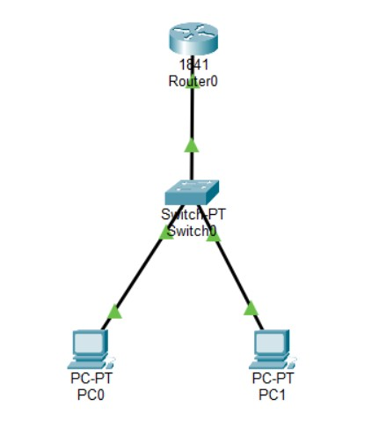

Code :
Router Configuration Commands:
Router>enable
Router#configure terminal
Router(config)#hostname DHCP-Router
DHCP-Router(config)#interface FastEthernet0/0

SIWS COLLEGE
DHCP-Router(config-if)#ip address 10.0.0.1 255.255.255.0

DHCP-Router(config-if)#no shutdown
DHCP-Router(config-if)#exit

DHCP Pool Configuration:
DHCP-Router(config)#ip dhcp pool STUDENT_NETWORK
DHCP-Router(dhcp-config)#network 10.0.0.0 255.255.255.0
DHCP-Router(dhcp-config)#default-router 10.0.0.1
DHCP-Router(dhcp-config)#dns-server 8.8.8.8
DHCP-Router(dhcp-config)#exit

Exclude IP Addresses:
DHCP-Router(config)#ip dhcp excluded-address 10.0.0.1 10.0.0.10
DHCP-Router(config)#exit
DHCP-Router#copy running-config startup-config

PC Configuration:
On each PC, go to Desktop tab → IP Configuration
Select DHCP option Verification cammand :
On Router:
DHCP-Router#show ip dhcp pool
DHCP-Router#show ip dhcp binding
DHCP-Router#show ip interface brief

On both PCs (Command Prompt):
C:\>ipconfig
C:\>ipconfig /all
C:\>ping 10.0.0.1

SIWS COLLEGE Output Results:
PC0 - ip config:

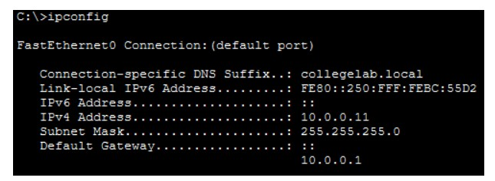

PC1 - ip config:

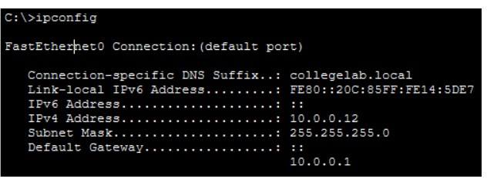

Router - DHCP Bindings (WORKING COMMAND):

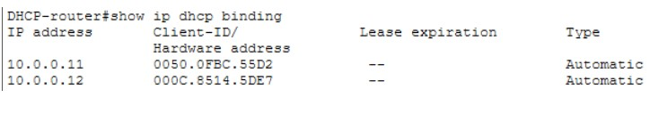

SIWS COLLEGE Router - DHCP Pool Status (WORKING COMMAND):
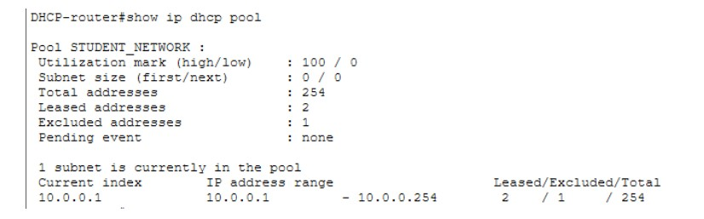

Router - Interface Status:
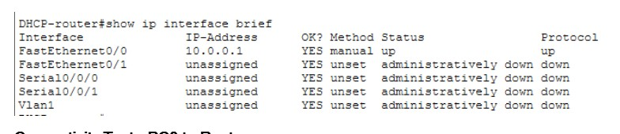
Connectivity Test - PC0 to Router:
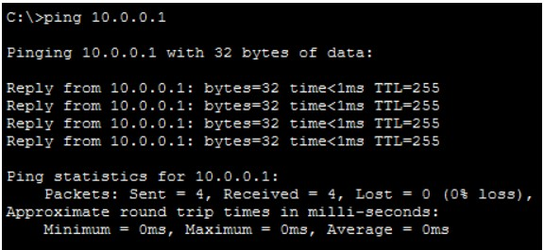

Conclusion: The DHCP server has been successfully configured on the router using commands compatible with Cisco Packet Tracer.

SIWS COLLEGE

